**Logical Development Of Vogel’s Approximation Method (LD-VAM): An Approach To Find Basic Feasible Solution Of Transportation Problem**

**PROPOSED ALGORITHM: LOGICAL DEVELOPMENT OF VOGEL’S APPROXIMATION METHOD (LD-VAM):**

**Step-1**: if s<0 and d<0, then Stop.

**Step-2:** if supply and demand is unbalanced then balance the transportation problem adding dummy demand or supply.

**Step-3**: a. **Identify the smallest and next to smallest cost of each row** and column and calculate the difference between them which is called by penalty. If smallest cost appear in two or more times in a row or column then select these same cost as a smallest and next to smallest cost and penalty will be zero.

**Step-4: Select lowest cost of that row or column which has largest penalties** in some rows or columns **then select that row or column which contains least cost among them**.

allocate maximum possible amount xij i.e, min , s di j . If the lowest cost appears in two or more cells in that row or column then choose the extreme left or most top lowest cost cell.If tie occurs in the largest penalties in some rows or columns then select that row or column which contains least cost among them.

eg.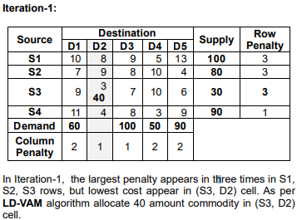

Step-5: Adjust the supply and demand and cross out the satisfied row or column. If row and column are satisfied simultaneously then crossed out one of them and set zero supply or demand in the remaining row or column.

Step-6: a. If exactly one row or one column with zero sun have (remaining) zero supply or demand, determined the zero basic supply or demand remains uncrossed out, Stop.If only one row or column with positive supply or demand remains uncrossed out, determine the basic variables in the row or column by the Least-Cost Method. c. If all uncrossed out rows or column variables by the Least-Cost Method. Stop. d. Otherwise go to Step-3.

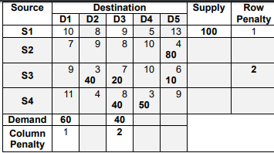

Only one row has remains with positive supply and demand amount then as per LD-VAM algorithm allocates these by Least Cost Method. The final feasible solution table is given below:

**PROVING WITH EXAMPLE**

|  |  |
| --- | --- |
| **QUESTION** | **SOLUTION** |